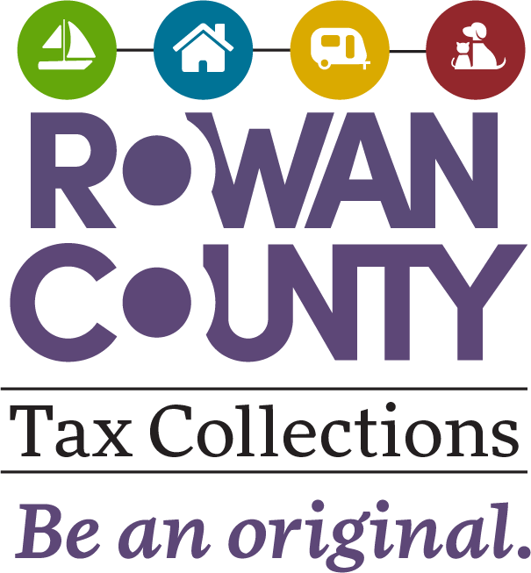

Rowan County Tax Collector
402 N Main St., Ste. 101 • Salisbury, NC 28144-4391
Telephone: 704-216-8544 FAX: 704-216-7983

New Beer & Wine License

Account #: _______________

Date: _____________ Effective Year: ___________

Business Name: ________________________________________________________

Owner Name: _________________________________________________________

Mailing Address: _______________________________________________________

City, State &Zip: ________________________________________________________

Phone: _________________________ Fax: _________________________________

Email Address: __________________________________________________________

Physical Location: _______________________________________________________

Contact Person: __________________________________________________________

Business Type: ___________________________Business Start Date: _____________

Do you have a Temporary Beer & Wine Permit from the state?
Yes___#____________________ No___

Occupation, Business, Etc. | General Statute | Fee
Malt Beverages, Retail Off Premises | 105-113.78 | $ 5.00
Malt Beverages, Retail On Premises | 105-113.78 | $25.00
Wines, Retail Off Premises | 105-113.78 | $25.00
Wines, Retail On Premises | 105-113.78 | $25.00

